**First page and icon of the app:**

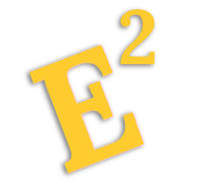

Let’s Begin

**Second page:**

Topic list

1. Wave Polarisation
2. Gauss’ Law

*(no numbering and no pictures for the topic list!)*

**Wave Polarisation- Basic Concepts page:**

There are several ways in which electromagnetic waves are capable of polarizing into. They are namely, circular polarisation, elliptical polarisation and linear polarisation.

All waves are typically elliptically polarized unless they meet the following conditions:

1. Both Ex and Ey have the same value AND there is a phase difference of $±π/2$
2. No phase difference

A results in the graph to be circularly polarized.

B results in the graph to be linearly polarized.

***(Pictures for this page:)***

First picture:

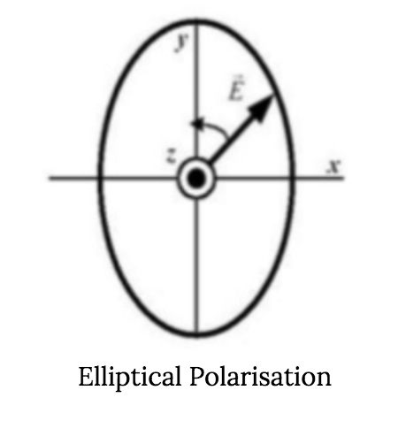

Second picture:

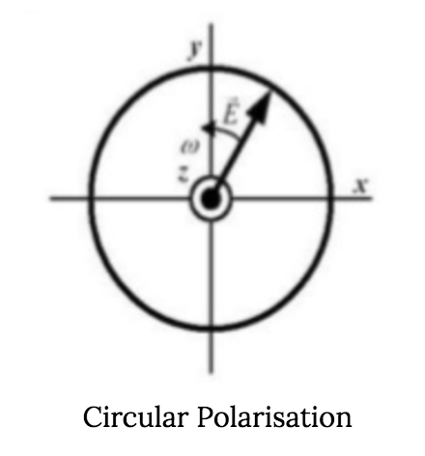

Third picture:

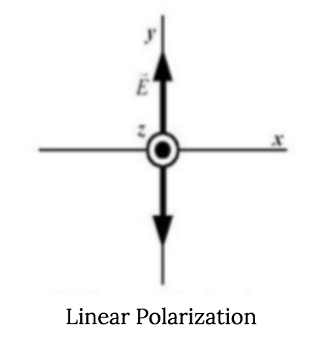

**Gauss’ Law**

What is the Gauss’ Law?

The electric flux passing through any closed surface is equal to the total charge enclosed by that surface.

Gauss’ law Equation:

$\oint_{S}{}$ D ${s∙dS}_{}$ = charge enclosed = Q

where Ds is the vector at the surface of the object and Ds normal (in the picture) is the vector that is normal to that portion of the surface.

This equation states that all charge enclosed within a surface is equal to the electric flux through the enclosed surface.

***(Pictures to place above the text:)***

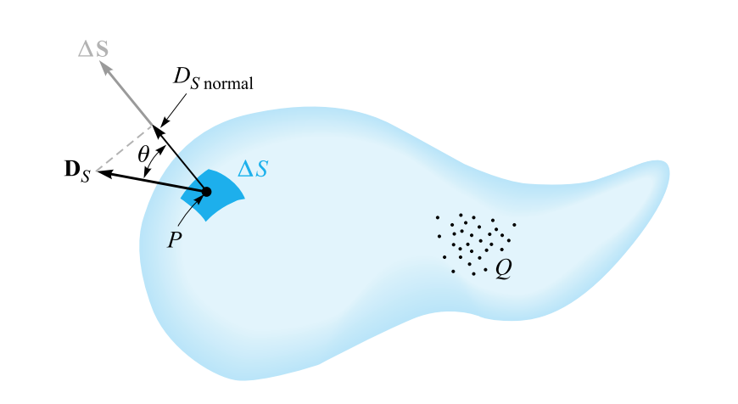

**Quiz for Gauss’ Law:**

1. Gauss's law due to different charge distribution is used to calculate
2. Electric field
3. Electric charge
4. Electric intensity
5. Electric field lines

Answer: C

2. A positive charge Q= 8 mC is placed inside the cavity of a neutral spherical conducting shell with an inner radius a and an outer radius b. Find the charges induced at the inner and outer surfaces of the shell.

A) Inner charge = –8 mC, Outer charge = +8 mC

B) Inner charge = +8 mC, Outer charge = -8 mC

C) Inner charge = 0 mC, Outer charge = +8 mC

D) Inner charge = –8 mC, Outer charge = 0 mC

E) Inner charge = 0 mC, Outer charge = 0 mC

Answer: A

3. Find the flux through a spherical Gaussian surface of radius a = 1 m surrounding a charge of 8.85 pC.

A) 1 x ${10 }^{-16}$ N $m^{2}$/C

B) 1 x ${10 }^{-12}$ N $m^{2}$/C

C) 1 x ${10 }^{-8}$ N $m^{2}$/C

D) 1 x ${10 }^{-4}$ N $m^{2}$/C

E) 1 N $m^{2}$/C

Answer: E